## UML Diagrams

### UML Use Case Diagram

### UML Activity Diagrams

### UML Sequence Diagram

### UML Class Diagram

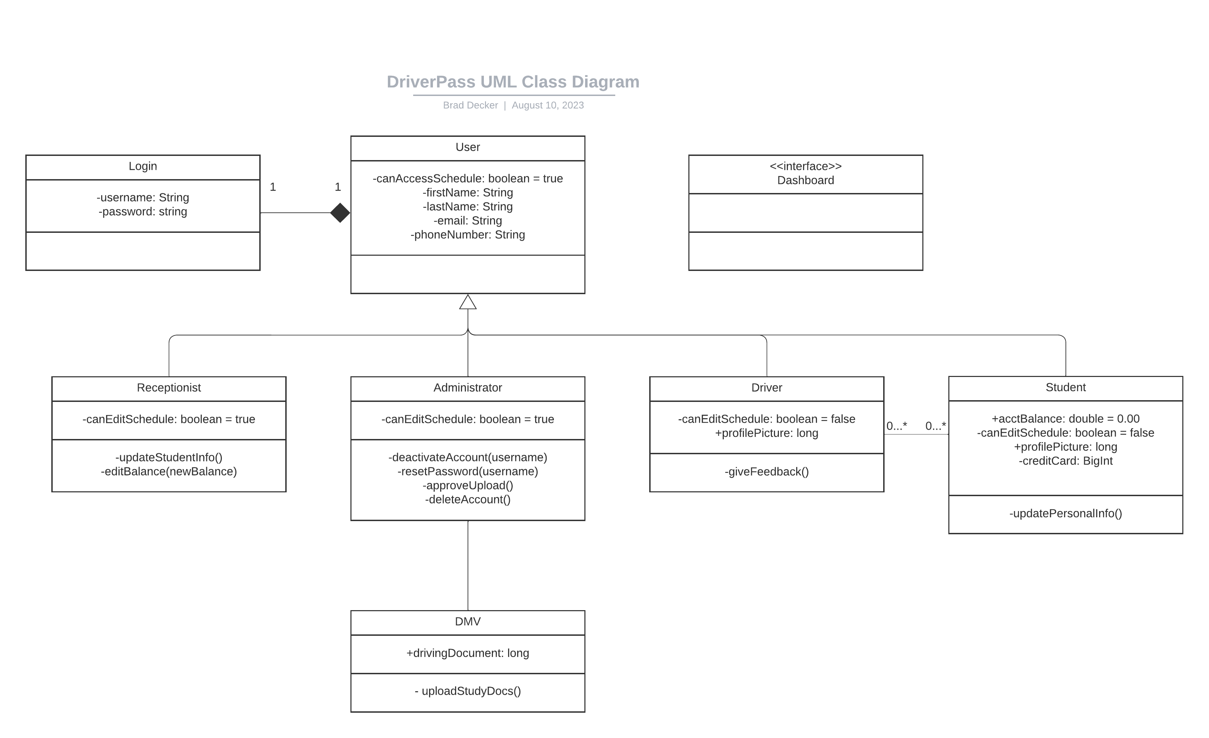

## Technical Requirements

Software Requirements

* Ubuntu LINUX Server to host the data.
* Mobile Application within both Apple store and Google Store.
* Web Browser support and a website to go along with it.

Hardware Requirements

* A computer, peripherals, mouse and keyboards for each receptionist or administrator.
* A mobile phone for each driver with an internet browser.

Tools

* [Landscape](https://ubuntu.com/landscape) for the Linux Server
* Java Virtual Machine for coding the system with Maven for multiple hosting applications.